A Sudoku Game That Coaches The Player
(Proposal)

By

Ron Cox
Florida Institute of Technology
CIS 5080 – Projects in Computer Information Systems

For

Mr. Steve Johnson
January 27, 2010

Introduction 3
Sudoku Basics 3
Sudoku Puzzle Solving Basics 4
Sudoku Sensei’s Value Proposition 5
Algorithms / Project Solution 7
Puzzle Structure 7
The Bigs 7
Associates 8
Puzzle Solving Techniques 8
One-Choice 8
Bigs Scanning 8
Elimination 9
Puzzle Persistence 9
Implementation 11
Platform 11
Development Tools 11
Programming Language and Code Libraries 11
Implementation Procedure 12
Schedule 13
References 15

Introduction
Sudoku Sensei will coach the user on how to solve Sudoku puzzles.
The result of this project will be a Sudoku computer game named “Sudoku Sensei” that coaches the user on how to solve Sudoku puzzles. Sudoku is an easy game to play in terms of the rules for the game. The rules are quite simple. However, the simplicity of the rules can be deceptive. Solving Sudoku puzzles can be quite difficult. Players develop and/or adopt any number of techniques to solve the puzzles. Simple techniques can be used to solve simple Sudoku puzzles. More difficult puzzles require more sophisticated techniques. Techniques that work for one puzzle will likely be far less effective on a more difficult puzzle.

Sudoku Basics
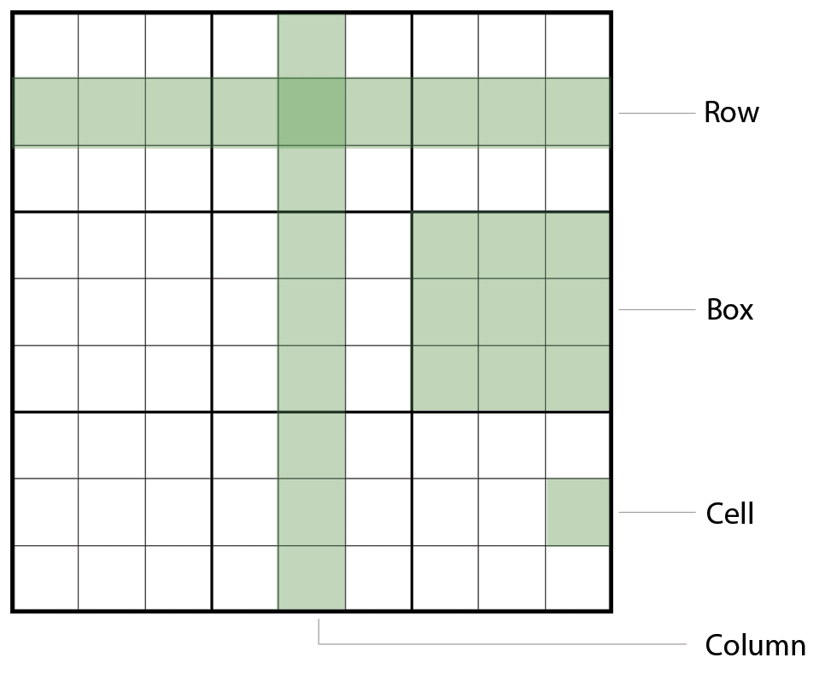
Sudoku is a number puzzle consisting of a 9 X 9 “grid” of “cells.” The grid has nine rows and nine columns. A “row” is a horizontal line of cells. A “column” is a vertical line of cells. The grid is further divided into nine 3 x 3 “boxes.” As you can see in Figure 1, the boxes are identified with bolder lines.
Figure 0: The Sudoku Grid

The rules of Sudoku are simple. Wilson (2006) cited the following three characteristics of a completed puzzle:
- Each row contains all the numbers from 1 to 9.
- Each column contains all the numbers from 1 to 9.
- Each 3 x 3 box contains all the numbers from 1 to 9.
The above can be summed up nicely as single rule: “The puzzle must end up with each row, column and box containing all the numbers from 1 to 9” (Stephens, 2007, p. 11).
Sudoku puzzles have no official standard for construction. Fortunately, there are a couple of rules that puzzle authors follow.
- The puzzle has a single solution. This is a critical point since a multi-solution puzzle requires guessing at some point, and that violates the next rule.
- No guessing. The puzzle can be solved with logic alone.
As you can see, the rules for puzzle construction are simple. Puzzle construction may not be a particularly easy task (most are computer generated), but the rules are simple.
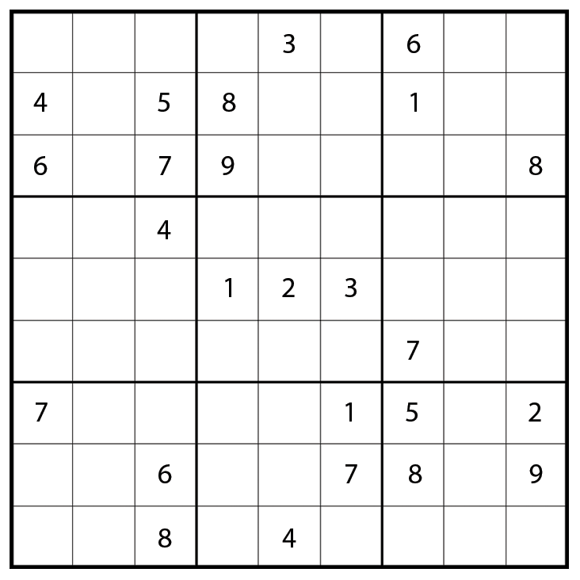
A puzzle starts with some number of the cells already filled in. These are commonly referred to as “givens.” (Another common term is “clues.”) It’s convention, although not actually a rule, that the givens appear in a symmetric pattern. This can be seen in Figure 2.
An additional convention is to limit the number of givens to 30. The idea is that more than 30 givens makes the puzzle too easy to solve. There is no rule or convention as to the minimum number of givens. Too few givens would make the puzzle unsolvable without guessing, which violates one of the previously stated rules.
Figure 2

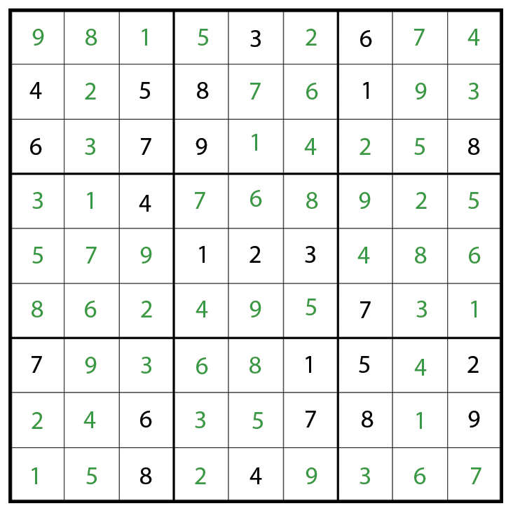
Sudoku Puzzle Solving Basics
Sudoku puzzles may look like math puzzles, but they’re not. They are logic puzzles. In fact, the use of numbers isn’t even necessary. Some Sudoku games use colored squares or marbles. Shapes could also be used. The puzzle simply needs to use nine distinct objects. The original Sudoku puzzles used numbers, and that style remains the most popular.
Figure 3: The solution to the puzzle in Figure 2
Solving a Sudoku puzzle requires only logic. It’s a matter of logically eliminating numbers from a cell until there is only one number that can occupy that cell. That one number is the solution for that cell. Do that for all the empty cells and the puzzle is solved.

Sudoku Sensei’s Value Proposition
Sudoku Sensei will have a number of puzzles preloaded. In addition, users will be able to enter puzzles they’d like to solve. The user will be able to solve a puzzle with no help from Sudoku Sensei, or may ask for help at any time. Upon request, Sudoku Sensei will coach the user on the simplest technique needed to solve the next cell in the puzzle. It will show the solution for that cell and identify the technique used to find that solution. In addition, the user will have the option to view a detailed explanation of the technique. As a result, the user will master the techniques required to solve Sudoku puzzles. Those techniques can be applied in any context, not just when solving puzzles in Sudoku Sensei.

Algorithms / Project Solution
This section describes the unique problem and the proposed solution that will be known as Sudoku Sensei.
The most significant challenge in implementing Sudoku Sensei will be designing and implementing the algorithms for solving cells. The books I’m using as references contain techniques for solving puzzles. In addition, I’ve developed my own techniques as I am an avid Sudoku player. Not surprisingly, the techniques I’ve developed on my own overlap with the ones in the books. The books also contain more advanced techniques than the ones I have developed. Those advanced techniques are useful for solving more difficult puzzles.
Since the goal of Sudoku Sensei is to teach the user techniques for solving puzzles, those puzzle solving techniques will have to be human techniques. This is in contrast to what one might develop if the goal was to have the computer solve the puzzle. A computer program would use different algorithms (e.g., backtracking) than a human uses.

Puzzle Structure

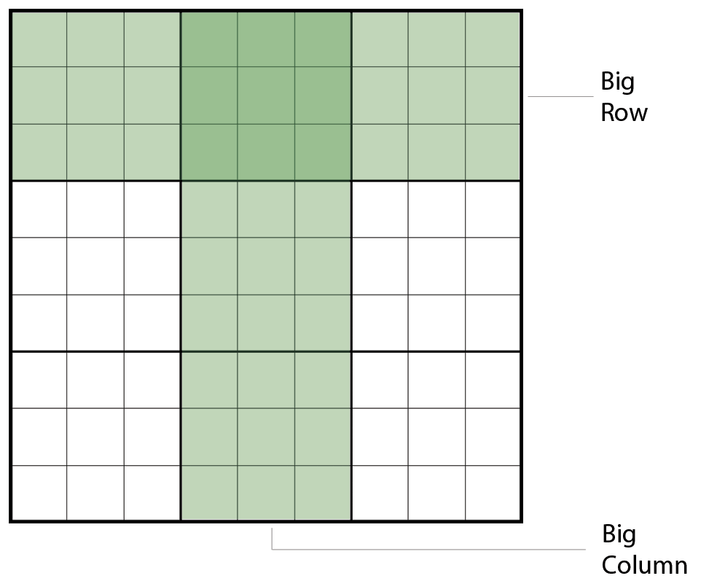
The Bigs
In the section titled Sudoku Basics, I introduced the elements of a Sudoku puzzle – the grid, row, column, box and cell. In addition to those constructs, Sudoku players also think of the puzzle in terms of “big rows” and “big columns” as shown in Figure 4. The bigs are employed in certain solving techniques.
Figure 4

Associates
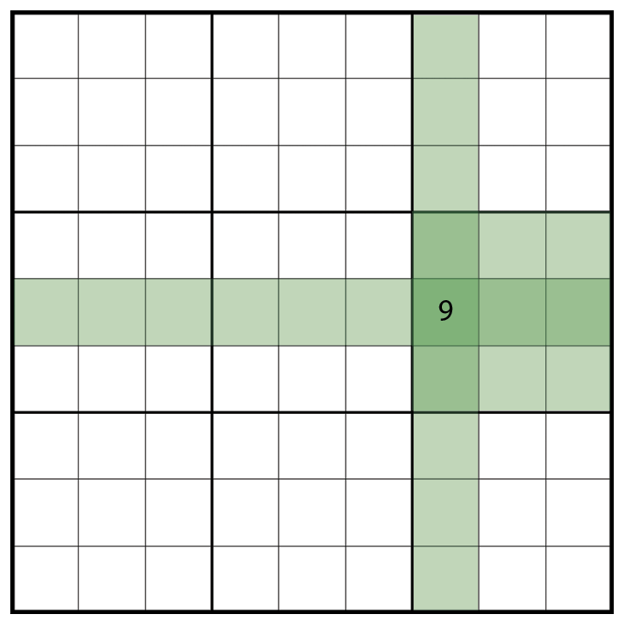
Remember that the rules for solving a Sudoku puzzle can be stated succinctly as: “The puzzle must end up with each row, column and box containing all the numbers from 1 to 9” (Stephens, 2007, p. 11). Each cell is part of a row, a column, and a box. What that means is the number in the cell has to be unique within the row, column and box the cell is a part of. For example, if the cell contains 9, no other cell in the row, column or box can contain 9. I call those other cells “associates.” Every cell has 20 associates - other cells that are part of its row, column or box. This is illustrated in Figure 5.

Puzzle Solving Techniques
Sudoku Sensei will have numerous puzzle solving techniques, listed below in order of complexity. Mastery of these techniques will enable a player to solve puzzles of easy to moderate difficulty.

One-Choice
The One-Choice technique is detailed in Gordon (2006) as follows: “Find a cell in which there is only one possible number that can go in the cell, and put it in.” This takes three forms: Box Completion, Row Completion, and Column Completion.

Bigs Scanning
We know that every row and column in a Sudoku puzzle must contain every number 1 to 9. Taking that a step further, we know that every big row and big column must contain every number 1 to 9 three times. With this technique we look for a big row or column where a number appears twice, meaning it appears in two of the boxes in that big row or column. We then attempt to identify where that number should go in the third box.

Elimination
This technique is related to One-Choice. It’s more complicate, sort of a Multi-Choice. However, that name wouldn’t be as descriptive as Elimination better captures the essence of the technique. With One-Choice the cell has only one possible number that can go in the cell. With Elimination the cell has more than one possible value. We use additional information to determine which of those possible values is the correct one for the cell. Possible values are known as “candidates.”
As an example, suppose we have a row that has only three empty cells. The first empty cell has the candidates 6, 7, and 8. The second empty cell has the candidates 6 and 8. The third empty cell has the candidates 6 and 8. The Elimination technique allows us to identify that 7 is the solution for the first empty cell. Even though that cell has three candidates, it is the only cell in the row that can contain the number 7. Therefore, the solution for that cell is 7.
In the above example I used a row, but this technique is applied to rows, columns, and boxes.

Puzzle Persistence
When viewed as data, a puzzle is a 9 x 9 array of cells. Sudoku Sensei will store a puzzle as a simple comma delimited string, with a space representing an empty cell. Storage will be in the form of a database. The puzzle table will store the beginning state of the puzzle, the solution, and the state when last saved. It will also store an indicator for how difficult the puzzle is (easy, medium, or hard).

Implementation
This section describes the resources that will be used to implement Sudoku Sensei.

Platform
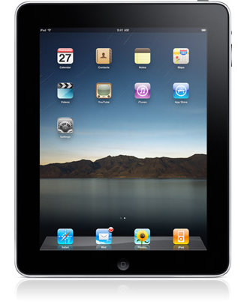
Sudoku Sensei will be an Apple iPad application. The iPad (http://www.apple.com/ipad ) is a new device from Apple. It is categorized as being a device that falls between an iPhone and a MacBook. From a software development point of view, it’s more similar to the iPhone because the iPhone SDK is used during software development for the iPad. All iPhone applications run on the iPad without modification. In addition, Apple has extended the iPhone SDK to support development of applications that are built specifically for the iPad.

Development Tools
Development will be done on Mac OS X using Apple’s Xcode IDE, Interface Builder and iPad simulator. Information and downloads can be found at http://www.apple.com/ipad/sdk and http://developer.apple.com/technology/tools.html. I’ll use Balsamiq Mockups (http://www.balsamiq.com/products/mockups )to design Sudoku Sensei’s user interface.

Programming Language and Code Libraries
Sudoku Sensei will be programmed in Objective-C 2, the “native” programming language on Apple’s family of operating systems. The only code library required is Apple’s new iPhone SDK.

Implementation Procedure
I plan to start by developing high-level use cases for the application. Also during this phase I’ll design the user interface with screen mockups. Next I’ll create a high-level (logical) class model using the modeling features in Xcode. Since Xcode’s class modeling uses the actual source code as the model, the high-level class model will provide skeleton code as a starting point for programming. From that point on I’ll develop code via both modeling and coding, using the method most appropriate for each situation. I’ll develop the data model late in the project, deriving it from the class model.

Schedule
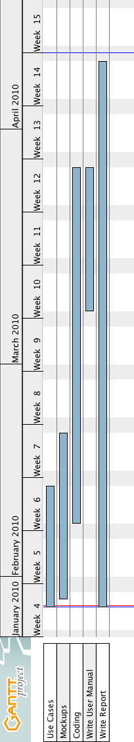

References
Gordon, P. (2006). Mensa guide to solving Sudoku. New York, NY: Sterling Publishing Co., Inc.
Stephens, P. (2007). Mastering Sudoku week by week. London: Duncan Baird Publishers.
Wilson, R. (2006). How to solve Sudoku. New York, NY: Sterling Publishing Co., Inc.

